AI ASSISSTED CODING LAB - 7.3

Name : P.Deepak
Roll no : 2303A52179
Batch : 42

Task 1: Fixing Syntax Errors
Scenario :
You are reviewing a Python program where a basic function definition contains a syntax error.

Code with syntax error
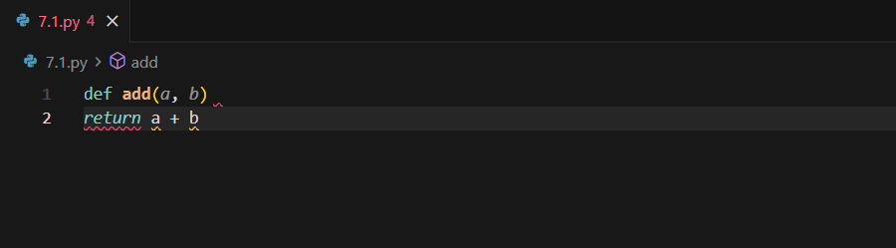

Expected output:
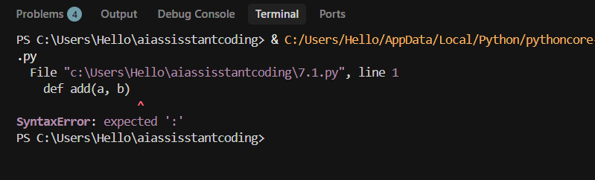

Error Identified by AI
Type of Error: SyntaxError
Reason: Python requires a colon (:) at the end of a function definition line.

Code debugged by ai
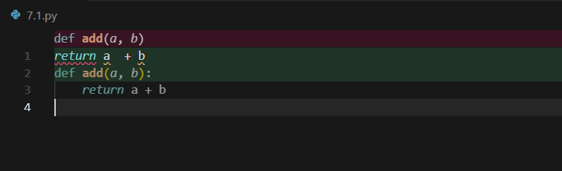

Output:
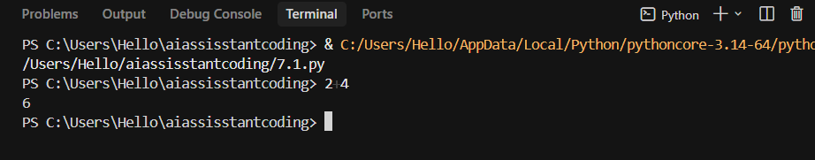

Explanation by AI :
The AI detected a syntax error because the function declaration line did not end with a colon. In Python, the colon indicates the start of an indented code block. Without it, the interpreter cannot parse the function body.
• AI-generated explanation of the fix

Task 2: Debugging Logic Errors in Loops
Scenario
You are debugging a loop that runs infinitely due to a logical mistake.
Requirements

Code with erros
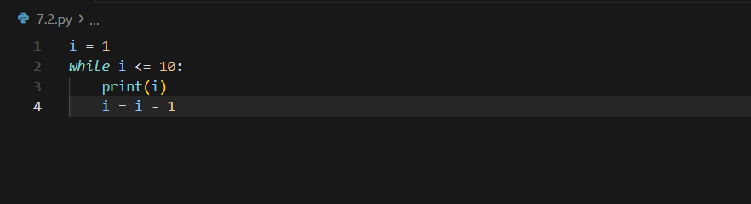

Error Identified by AI
Type of Error: Logical Error
Reason: The loop variable is decremented instead of incremented, so the condition i <= 10 is always true.
Code debugged by ai
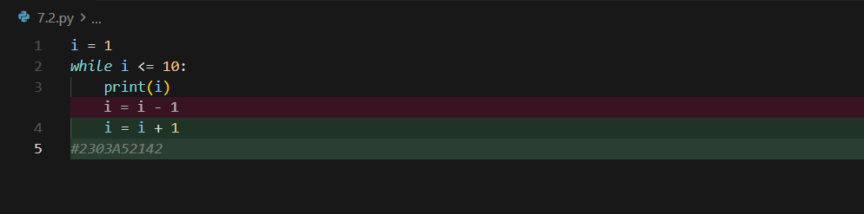

Output:
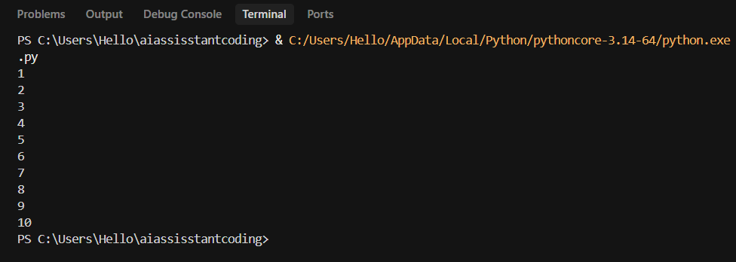

Explanation by AI
The loop condition depends on i increasing toward a stopping point. Decrementing i causes it to move away from the termination condition, resulting in an infinite loop.

Task 3: Handling Runtime Errors (Division by Zero)
Scenario
A function crashes due to division by zero.

Buggy code
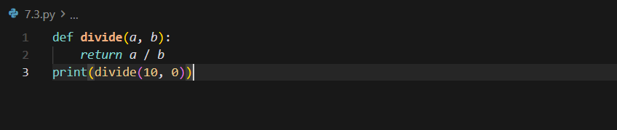

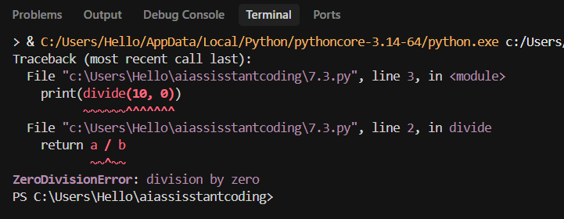

Error Identified by AI
Type of Error: Runtime Error (ZeroDivisionError)
Reason: Division by zero is mathematically undefined.

Debugged code
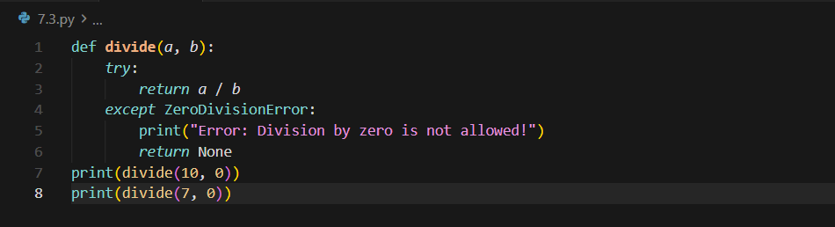

Output:
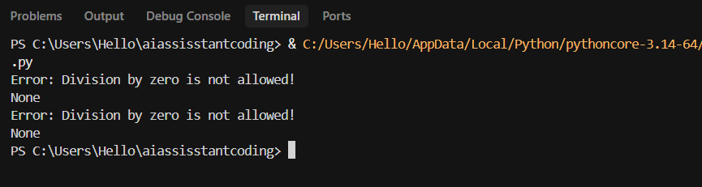

Explanation by AI
The AI added exception handling using try-except to prevent program termination. This ensures graceful handling of invalid input instead of crashing the program.

Task 4: Debugging Class Definition Errors
Scenario
A Python class constructor is incorrectly defined without the self parameter.

Buggy Code
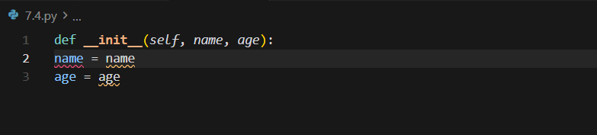
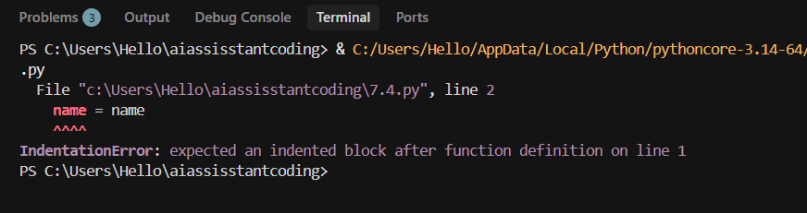

Error Identified by AI
Type of Error: TypeError / Object-Oriented Error
Reason: The self parameter is mandatory for instance variable access.

Debugged code
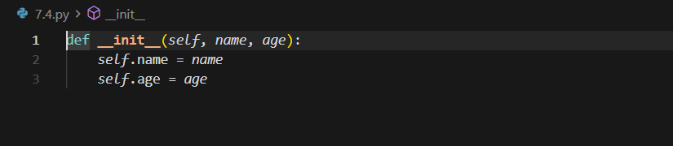

Explanation by AI
The self parameter represents the current object instance. Without it, instance variables cannot be properly assigned or accessed.

Task 5: Resolving Index Errors in Lists
Scenario
A program crashes when accessing an invalid list index.

Buggy Code
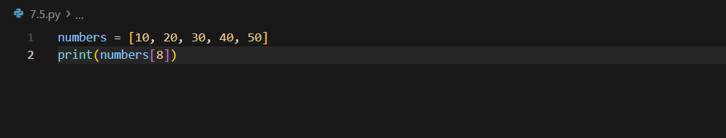
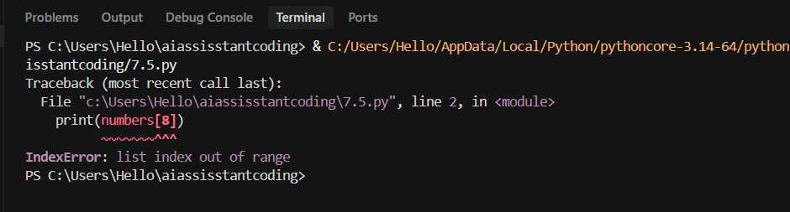

Error Identified by AI
Type of Error: IndexError
Reason: Index is outside the valid range of the list.

Debugged code
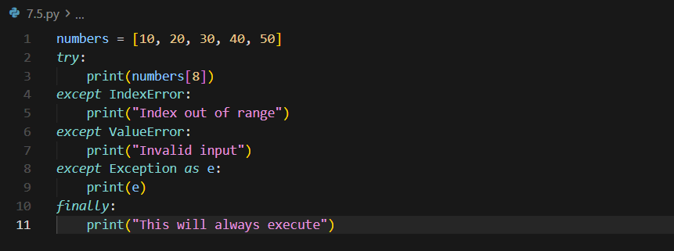

output:
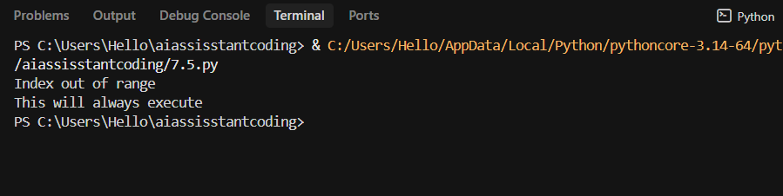

Explanation by AI
The AI suggested two safe approaches: checking the index against list length or handling the exception using try-except. Both prevent program crashes.

